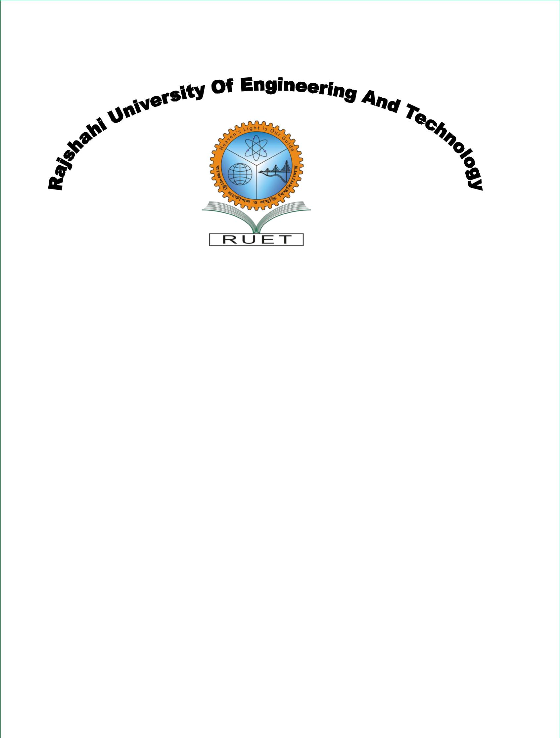

|  |  |  |  |  |  |
| --- | --- | --- | --- | --- | --- |
| **Department Of Computer Science And Engineering**  **Lab Report** | | | | |  |
| ***Submitted By*** | | | ***Submitted To*** | |  |
| Name: Ashadullah Shawon | | | Md. Rabiul Islam | |  |
| Class: 4th year, Even semester | | | Professor | |  |
|  | | |  | |  |
| Roll No: 133009  Course No : CSE 4204 | | | Department Of CSE  RUET, Rajshahi | |  |
|  | |  |
|  | | |  |
|  |
|  | | |  |
|  |  |
|  |  |
|  |  |
|  |  |